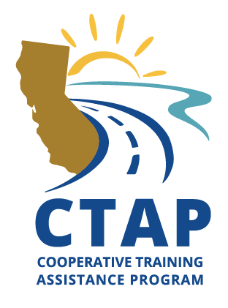
AGENDA
Federal Aid Series
Environmental Requirements
VIRTUAL Delivery - Zoom

Day 1
8:30 Introductions
Overview – Federal Aid Project Delivery
Environmental Resources
9:30 Break – 10 mins
Introduction to NEPA
Class of Actions
10:30 Break – 10 mins
PES-Non-Infrastructure
Revalidations
11:30 Break – 10 mins
Final Design & Permits
NEPA & Construction
Q&A, Wrap Up, & Close
12:30 Adjourn

Day 2

8:30 Overview of Day 1 and Q&A
PES Form & Process; Overview of Hypothetical Project
9:30 Break – 10 mins
PES Workshop
10:30 Break – 10 mins
PES Workshop
11:30 Break – 10 mins
Environmental Document Templates & Checklists
Pop Quiz
Q&A, Evaluations
12:30 Adjourn

